
Issue Buddy Tools
Version 1.0.0 | June 2026
Issue Buddy Tools is a collection of tools designed to assist Autodesk Revit users during the final stages of information delivery. The add-in includes five efficient quick-action commands that allow you to:
- Set up custom print sets using the CreatePrintSet command.
- Export dynamically named PDFs and DWGs using the PDFSplitter.
- Clean and protect project data using the ModelStripper.
- Visualize historical sheet revisions across the entire model via the RevisionViewer.
A workflow bonus tool is also included. Every feature is engineered to streamline final submittal and information delivery processes, saving countless hours.
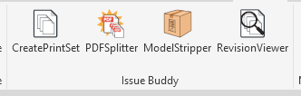
Below is a brief overview of the tools included in this set.
- CreatePrintSet
Use this tool to generate a Revit print set driven entirely by sheet revisions. Simply select a single revision or a range of revisions, specify a name, and click OK. It’s that simple.
With this tool, you will never accidentally miss a revised sheet in your submittal package.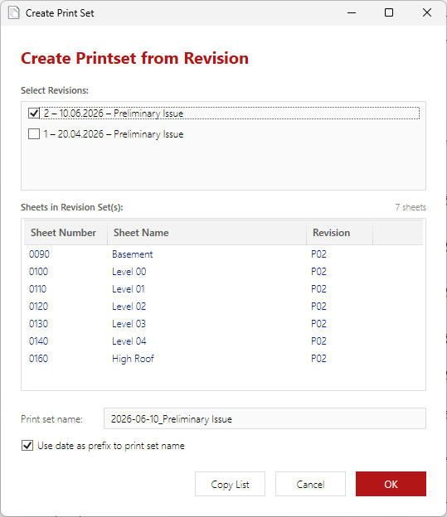+

- PDFSplitter
Once a print set is generated, print it to a single combined PDF using your preferred PDF driver (ensuring the option "Combine multiple selected views/sheets into a single file" is enabled). This combined file is used as the base input for the next step.
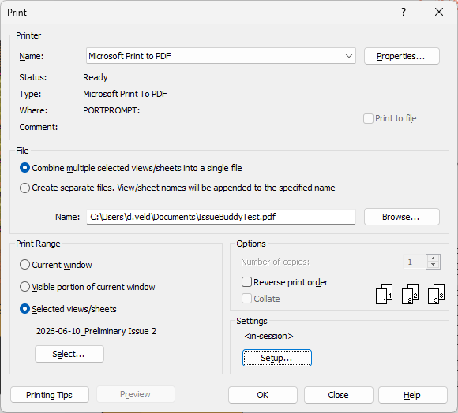

The PDFSplitter reads the combined document and splits it into individual files matching the page order of your print set. One by one, it generates neatly separated PDFs and accompanying DWGs.
- Full Naming Control: Customize your output file names dynamically using any available project or sheet parameters.
- Reusable Templates: Save your parameter mappings as naming presets to seamlessly match company or client information protocols.

Here is how it works:
Step 1: Select your combined PDF or drag and drop it directly into the target UI box.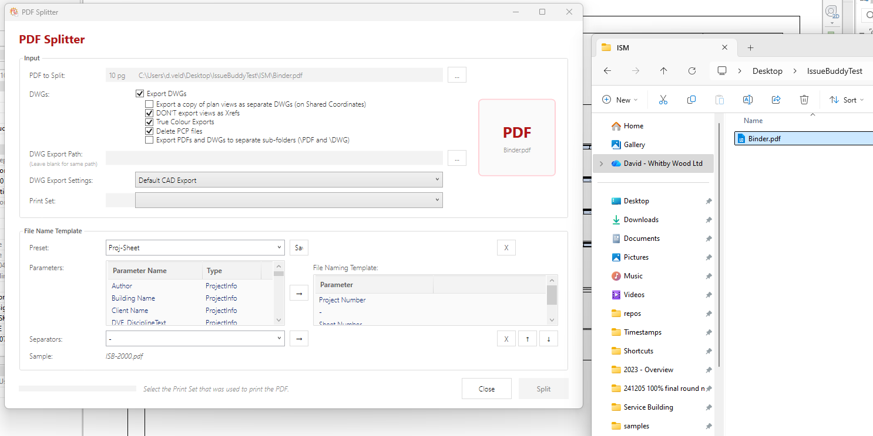
Step 2: Select your preferred DWG export settings, choose the matching print set (the one used to print your combined PDF), and select or create a naming template.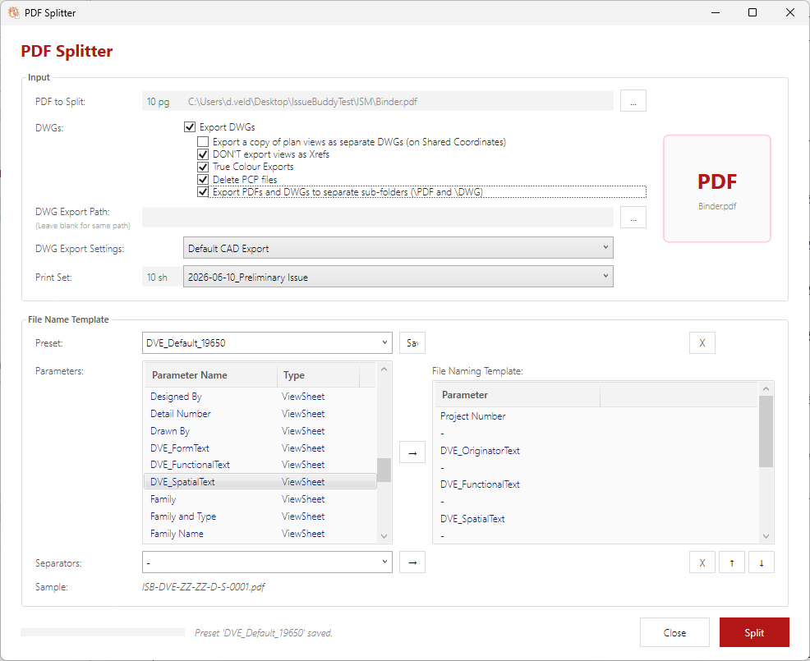
Step 3: Click Split. The tool will process the document, generating individual PDFs and corresponding DWGs in your target output directory.
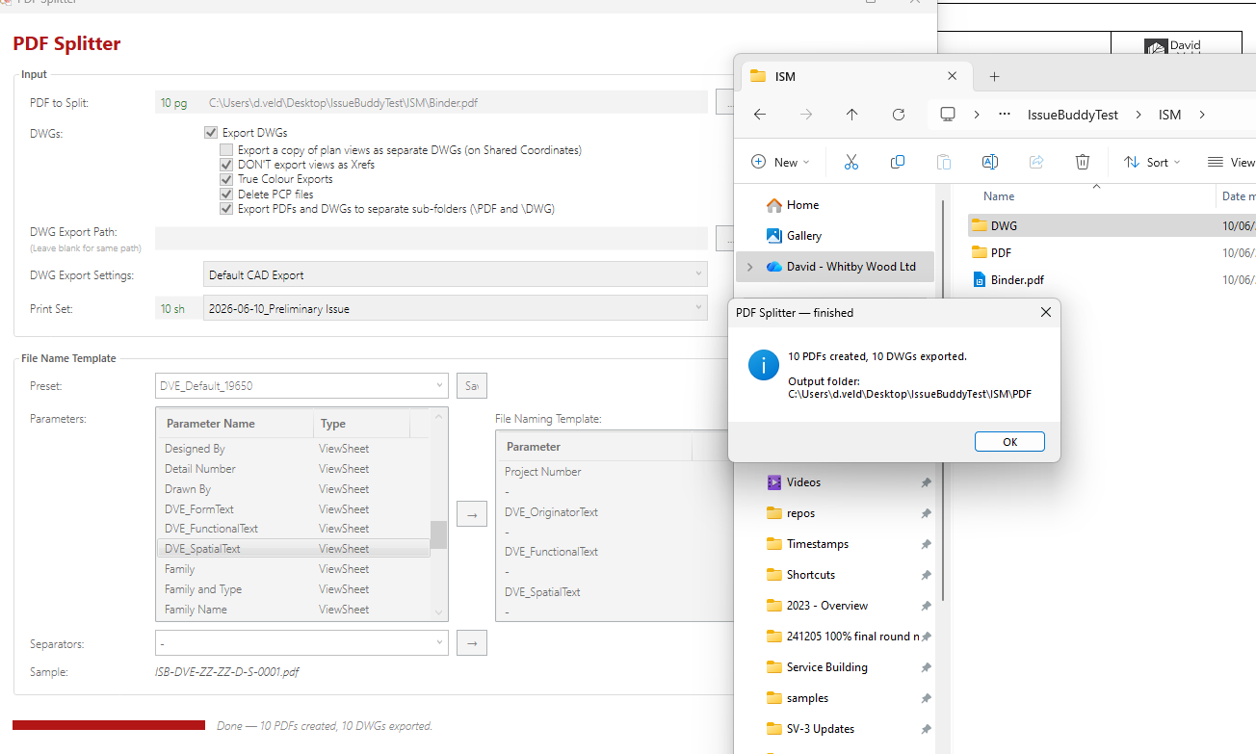
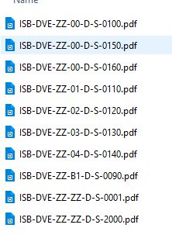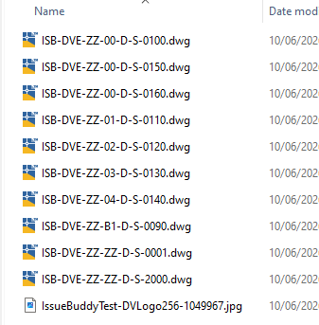

ModelStripper
The ModelStripper exports and strips a Revit model to a specified location. Users can select exactly which non-model components (such as views, sheets, legends, schedules, links, or groups) to strip away prior to export.
A central file, or a cloud based shared model will automatically become detached from it’s source.
After processing, the tool automatically prompts the user to purge unused elements, trimming the file down to its most compact and secure version.

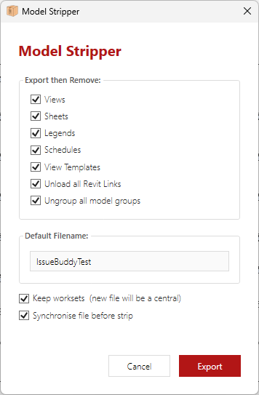

RevisionViewer
The RevisionViewer allows you to inspect both current and historical revisions across all sheets within the active Revit model. It provides a clean, table of your revision streams, making it effortless to cross-check sheet statuses, compile issue records, or generate Task Information Delivery Plans (TIDPs).
The completed matrix table can be exported directly to a CSV file for external documentation and project tracking workflows.
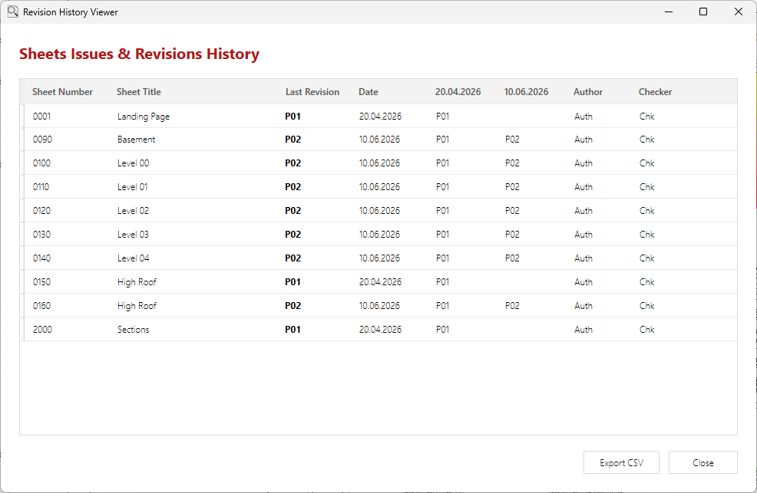

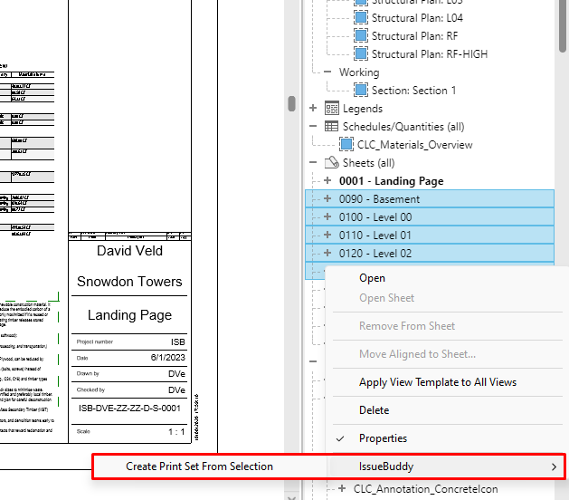
Bonus Tool: Print Set from Selection
When Issue Buddy Tools are installed, a custom context-menu command is integrated directly into the Revit Project Browser.
Simply highlight a selection of sheets in your Project Browser, right-click, and choose IssueBuddy -> Create Print Set from Selection. It is fast, intuitive, and eliminates manual list building.

*Note: This specific context-menu feature is supported in Revit 2025 and higher.

